**Project Design Phase-II**

**Data Flow Diagram & User Stories**

|  |  |
| --- | --- |
| Date | 24 June 2025 |
| Team ID | LTVIP2025TMID30187 |
| Project Name | Optimizing User, Group, and Role Management with Access Control and Workflows |
| Mentor Name | Dr Shaik Salma Begum |
| Maximum Marks | 4 Marks |

**Data Flow Diagrams:**

A **Data Flow Diagram (DFD)** for this project illustrates how project tasks, user roles, and workflows interact within the system. The diagram highlights the entry of user task data, its transformation through business rules, and its controlled visibility via access control mechanisms. Core entities include Project Manager (Alice), Team Member (Bob), Project Tasks, and the Access Control Layer.

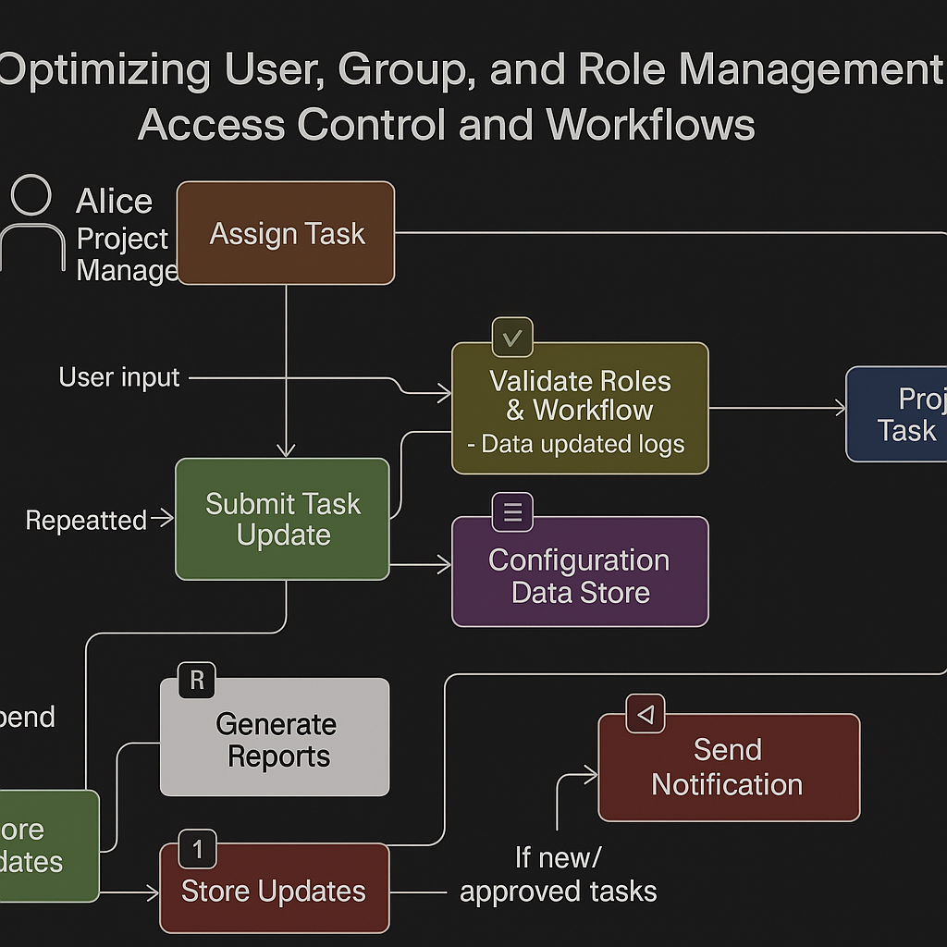

**User Stories**

Use the below template to list all the user stories for the product.

|  |  |  |  |  |  |  |
| --- | --- | --- | --- | --- | --- | --- |
| **User Type** | **Functional Requirement (Epic)** | **User Story Number** | **User Story / Task** | **Acceptance Criteria** | **Priority** | **Release** |
| Developer (Admin) | ServiceNow Setup | USR-1 | As a developer, I can set up a Personal Developer Instance for the role-based task tracking system | Instance is active and configured | High | Sprint-1 |
| Developer (Admin) | Role & Group Setup | USR-2 | As a developer, I can define Project Manager and Team Member roles with appropriate access permissions | Roles are assigned and enforce access restrictions | High | Sprint-1 |
| Developer (Admin) | Table Creation | USR-3 | As a developer, I can create a Project Tasks table with task name, assignee, status, and deadline | Table is created with all required fields | High | Sprint-1 |
| Developer (Admin) | Form Customization | USR-4 | As a developer, I can customize task forms for different user roles | Project Manager sees all tasks, Team Member sees only assigned tasks | High | Sprint-2 |
| Developer (Admin) | Access Control (ACLs) | USR-5 | As a developer, I can configure ACLs to restrict visibility and edit access by role | Only authorized users can edit/view based on roles | High | Sprint-2 |
| Developer (Admin) | Workflow Automation | USR-6 | As a developer, I can automate task approval and notifications | Email/notification is triggered on submission/update | Medium | Sprint-2 |
| Project Manager (Alice) | Task Management | USR-7 | As a manager, I can assign, update, and approve tasks | Tasks can be tracked and changed only by Alice | High | Sprint-2 |
| Team Member (Bob) | Task Execution | USR-8 | As a team member, I can view and update only my assigned tasks | Bob can access only tasks linked to him | Medium | Sprint-2 |
| Project Manager | Monitoring | USR-9 | As a manager, I can view dashboards or reports on team progress | Dashboard loads data based on task completion/status | Low | Sprint-3 |